ENGSCI 9510 Assignment 3 - Xinyu Yun

**Question 1**

A: Considering the group members are all stakeholders, and everyone has specific need to communicate to each other. If we use the graph to demonstrate the communication path, it would be a fully connected graph.

1. When n= 4

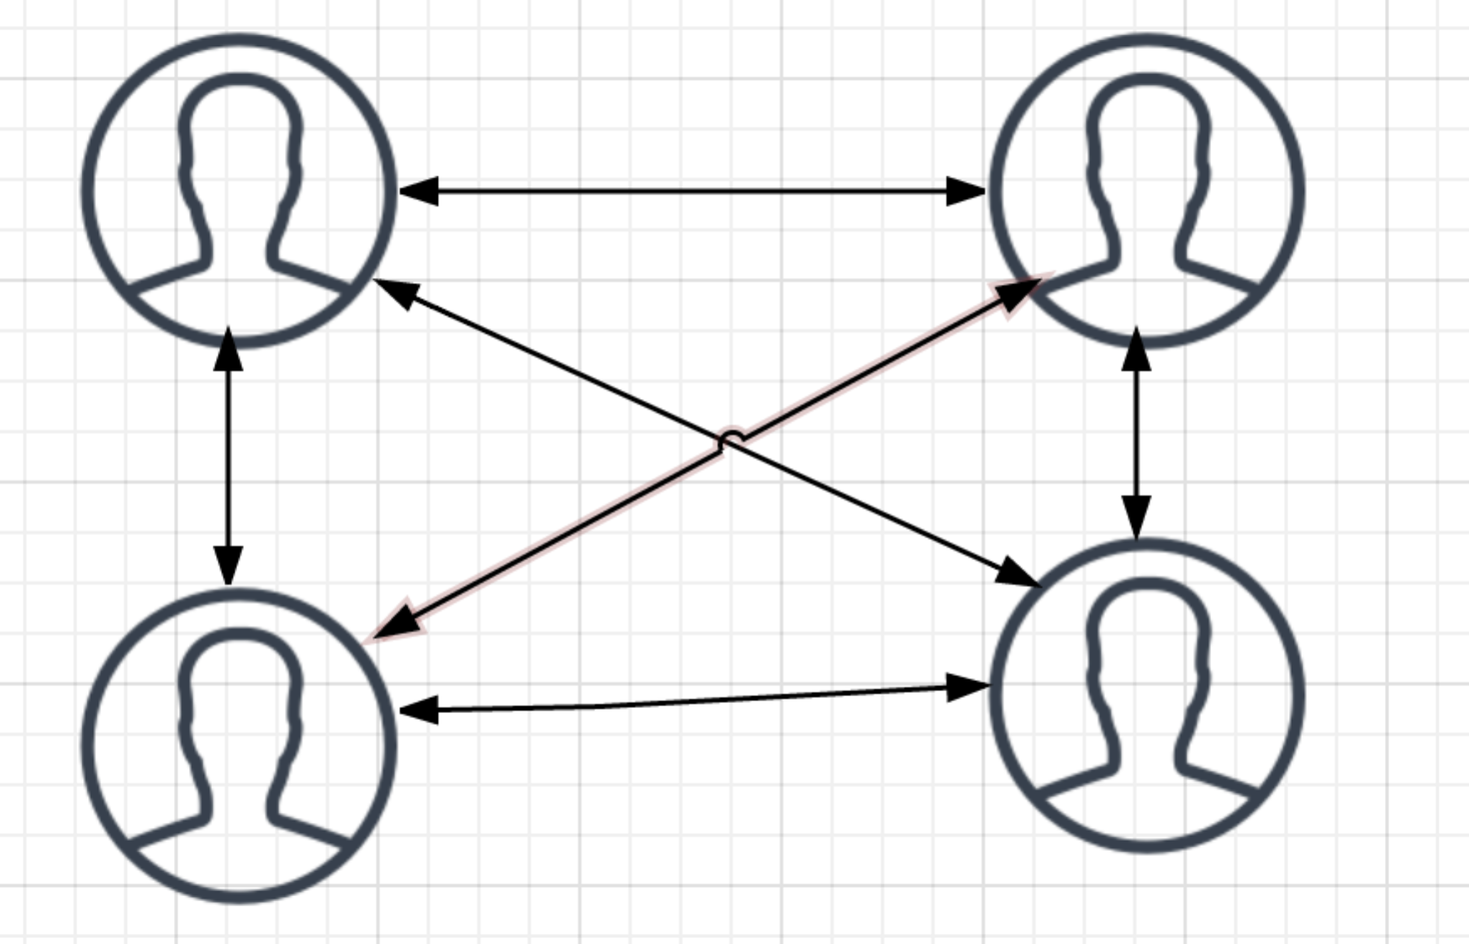

In this case the number of communication paths is 4*(4-1)/2 = 6

1. When n=5

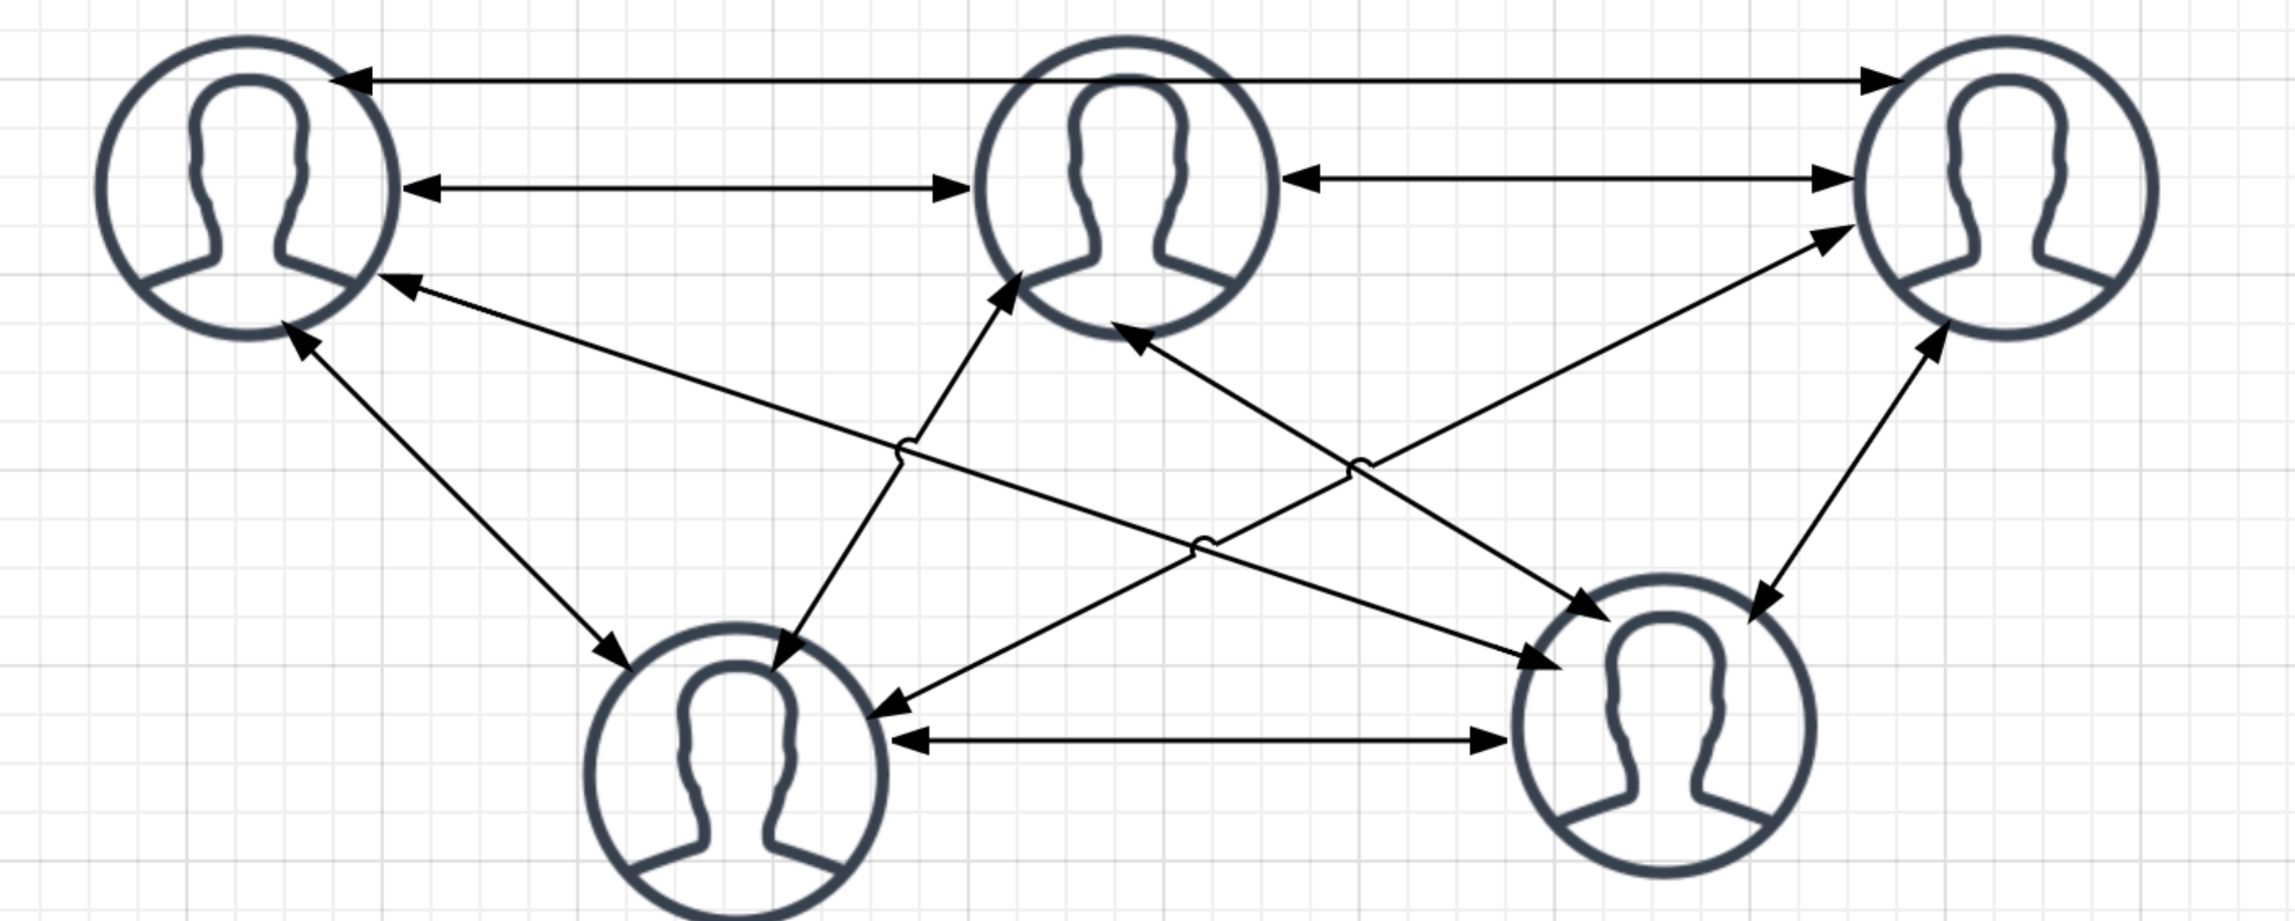

In this case the number of communication paths is 5*(5-1)/2 = 10

1. When n=6

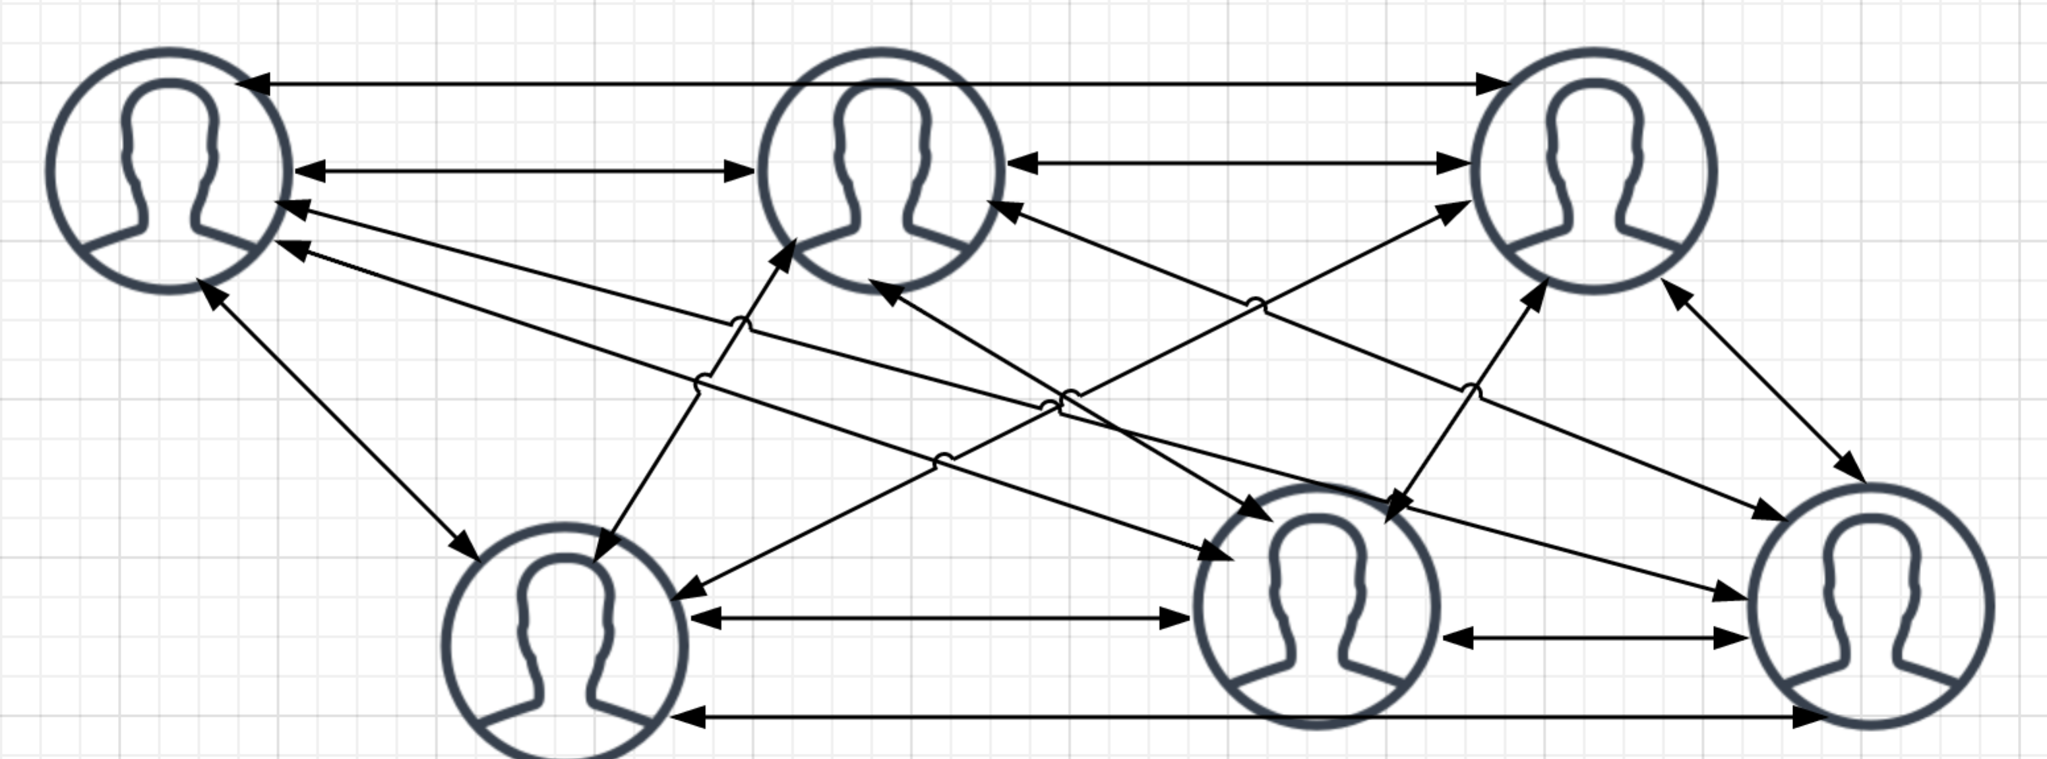

In this case the number of communication paths is 6*(6-1)/2 = 15

1. When n=7

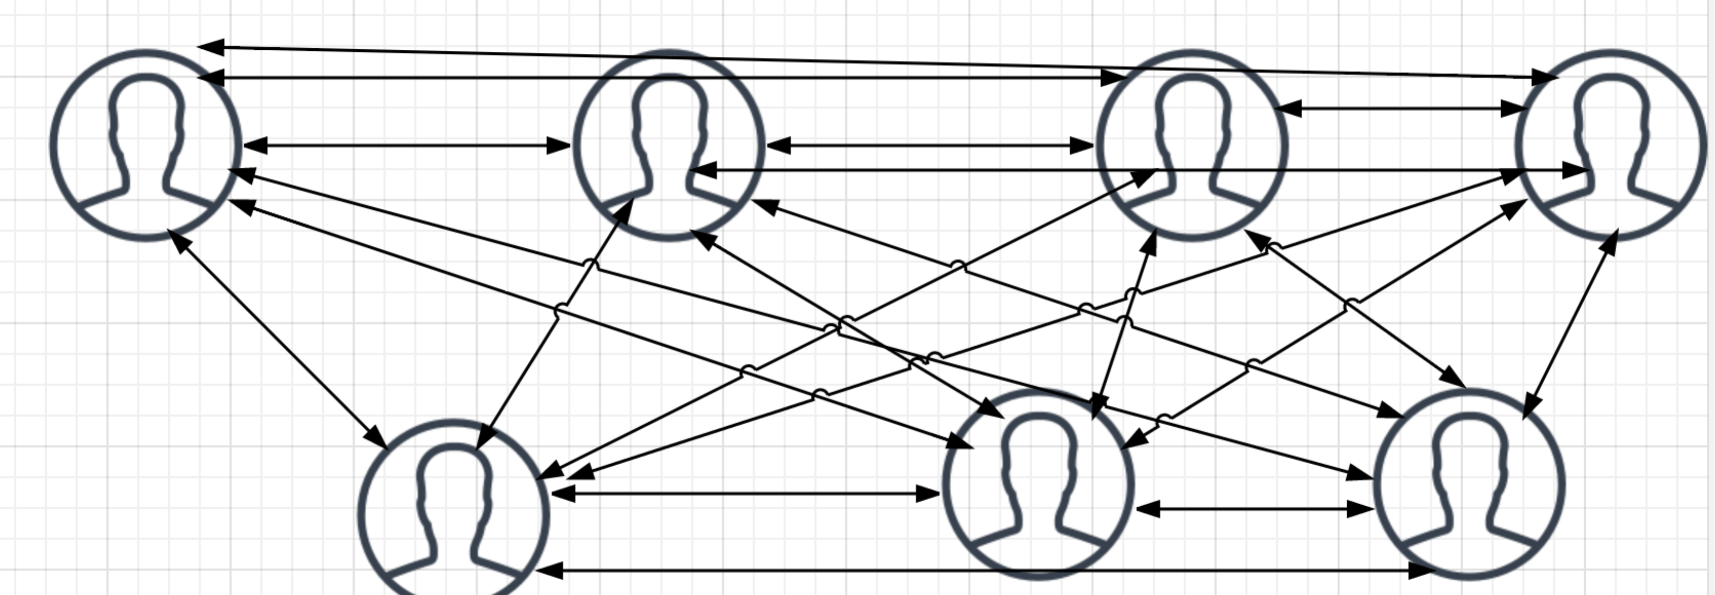

In this case the number of communication paths is 7*(7-1)/2 = 21

Based on calculation upon, the more numbers of people get involved, the more communication paths it has and the increasing trend is exponential.

B: in this scenario, there is one key person who communicates and coordinates with the others, every communicate path will pass him instead of every can communicate each other, according to which the number of paths will be reduced.

1. When n = 4

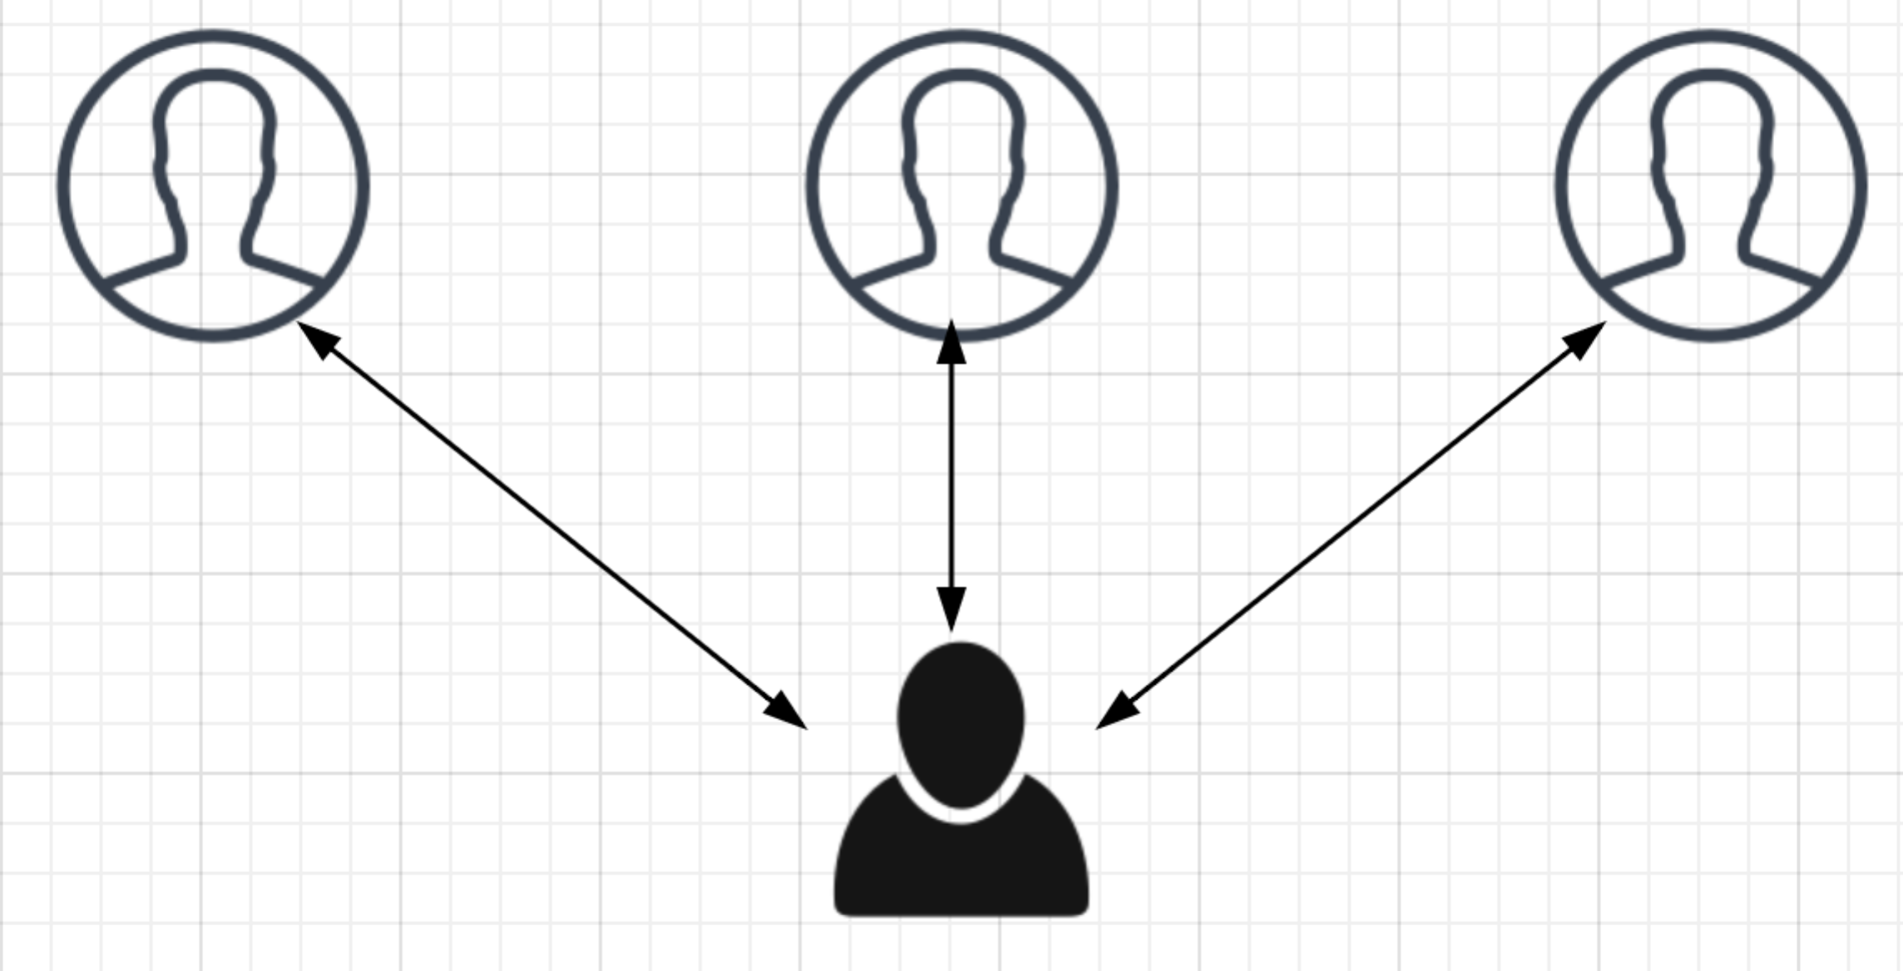

In this case we can tell only 3 paths exist.

1. When n = 5

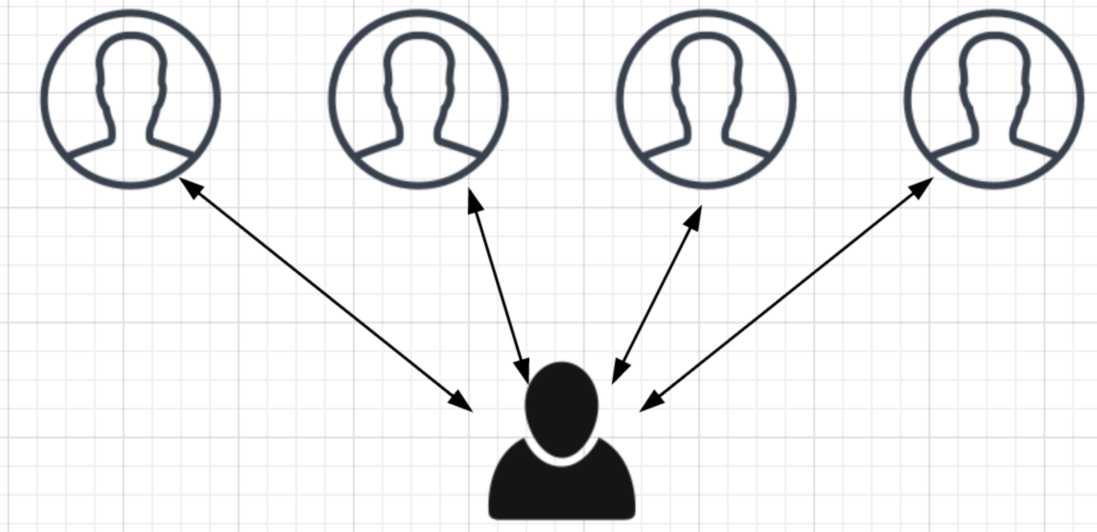

As we can see the communication paths number is 4

1. When n = 6

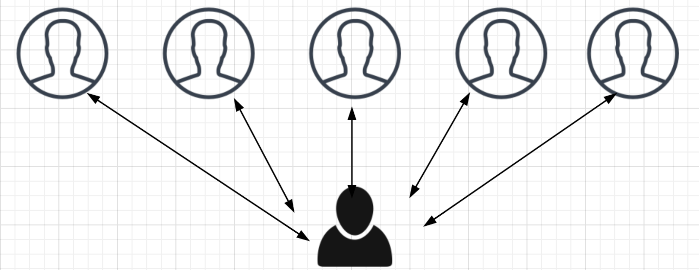

Number of communication paths is 5

1. When n = 7

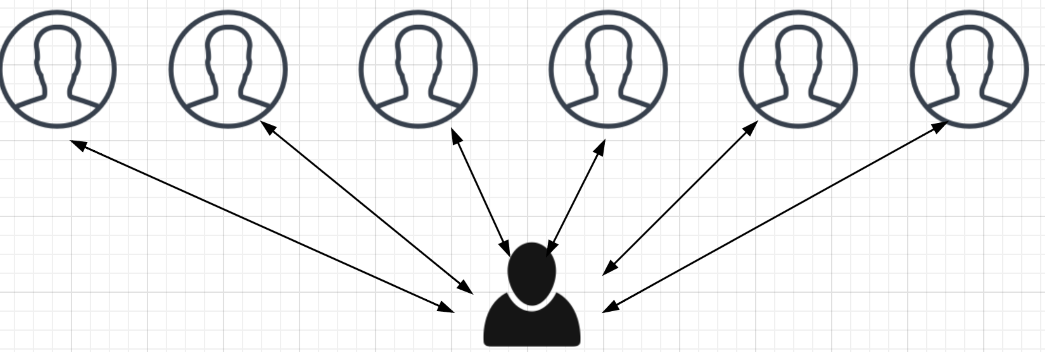

Number of communication paths is 6.

As the demonstrated graphs above, we can summarize the equation of this scenario is **n-1**, which is only increased in liner trend.

With this way the communication will become more efficient than scenario A.

Conclusion:

As a PM, when we try to organize or attend a meeting, we should fully consider the stakeholders’ number and communication style, generally you have to provide or align an agenda with the key person firstly so that we are on the same page about the goal of meeting, then the best situation is only the decision maker or direct stakeholders will be invited to make sure they can confirm the key points in the meeting or review the meeting minutes to confirm after the meeting in a short time. Anyway the meeting appears to the most efficient way to let all stakeholders sitting together to make decision instead of be melted in the emails’ volcano and got no any final decisions which will influent the project progress seriously. Meanwhile efficient communication will help PM well manage the time schedule and earn more buffers to focus on the critical activities.

**Question 2**

A: Please see the following result, EV is computed based on the EV rules and percentage of complete (if that period applies the rule 1)

PV is calculated by the table from baseline ‘Baseline Budget Needs by Time Periods 1- 14’

CV = EV – AC; SV = EV – PV

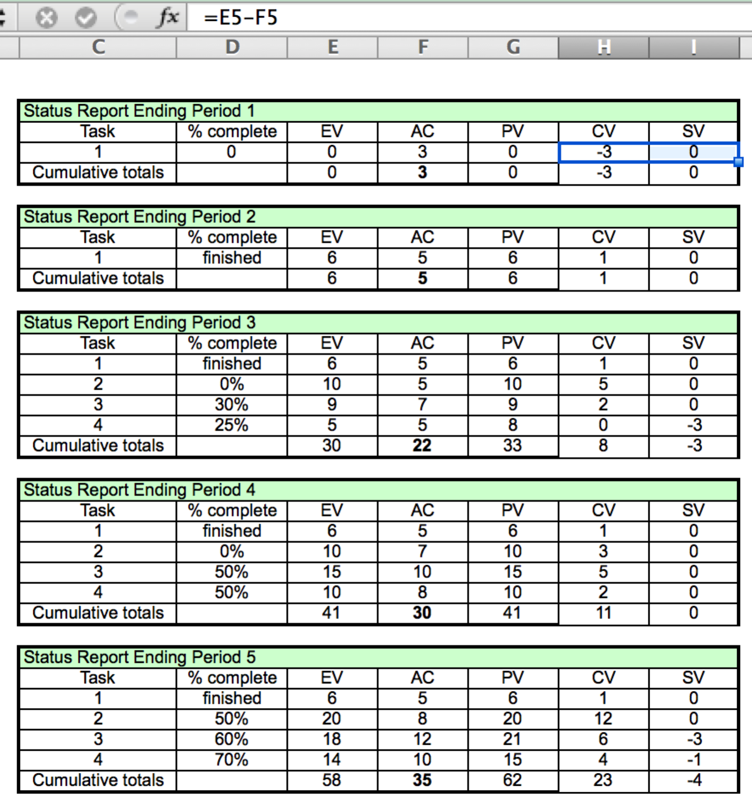

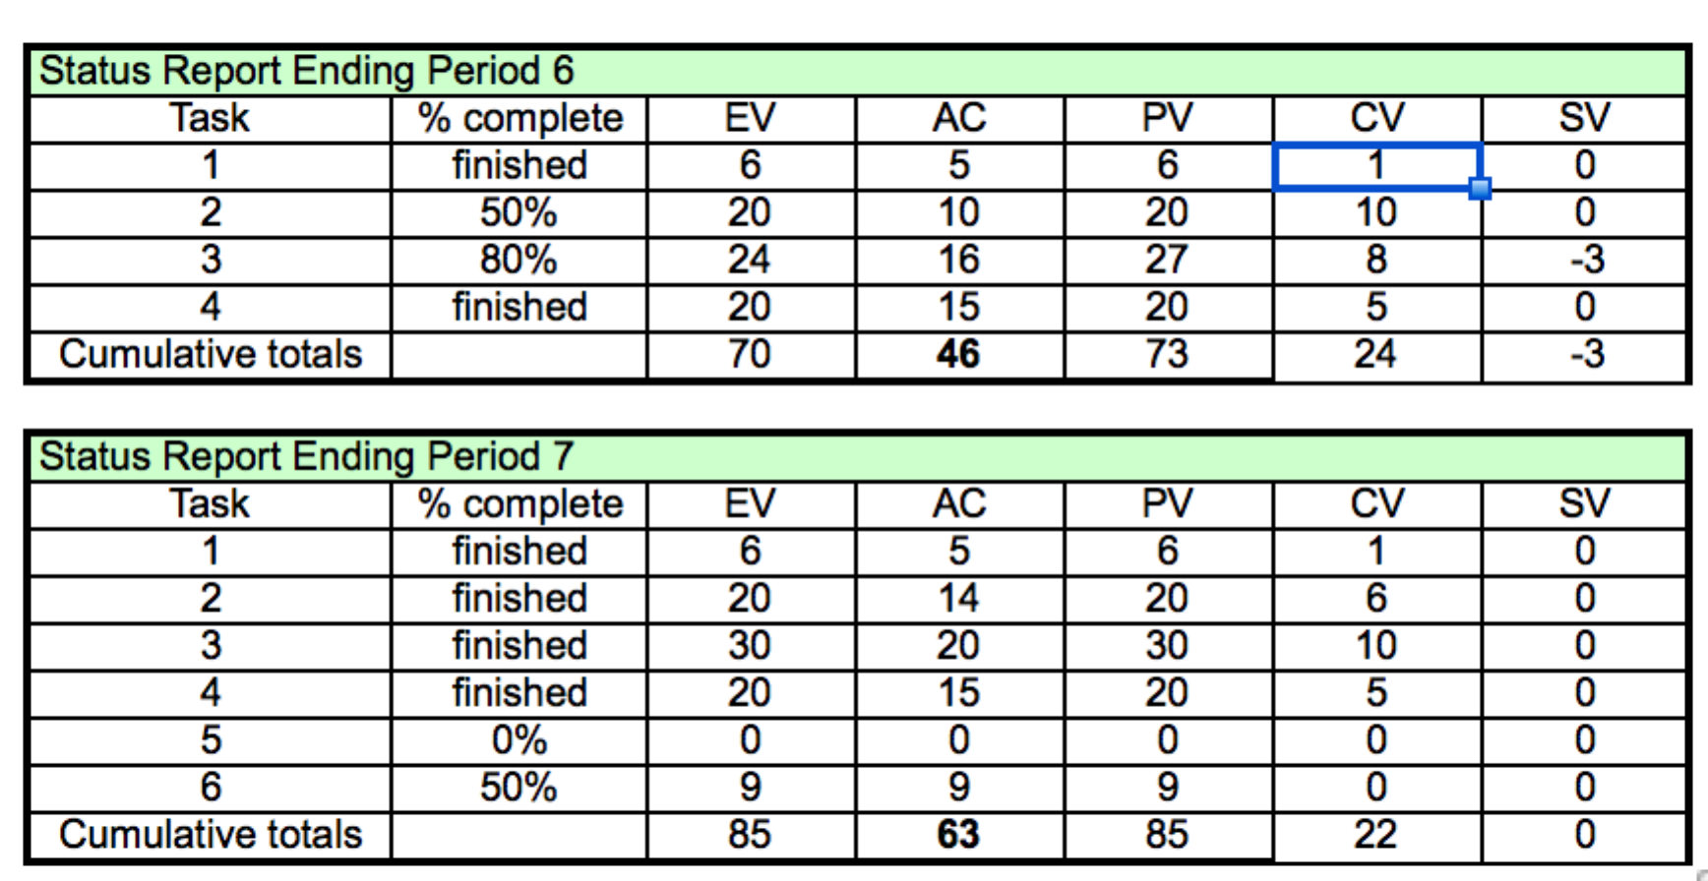

Based on the result above, the SPI, CPI and PCIB are calculated as bellowed:

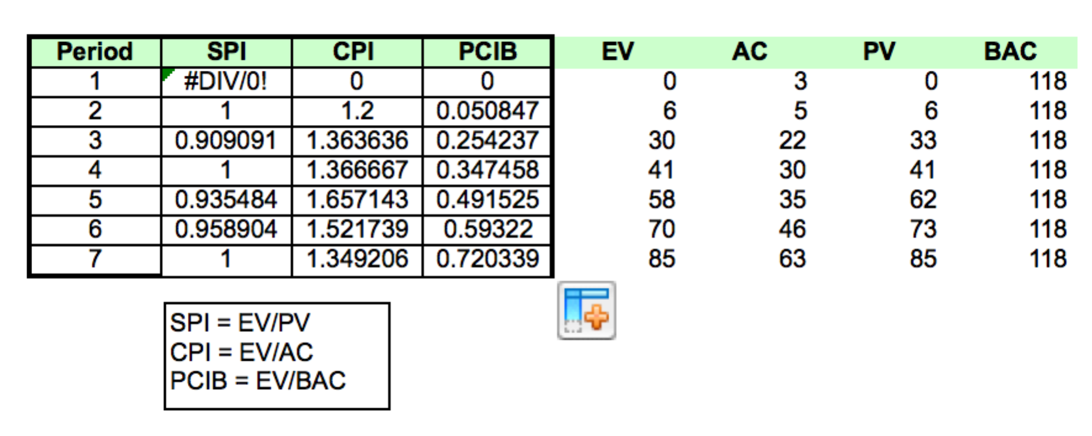

B: Pilot of EV and AC from period 1 to period 7:

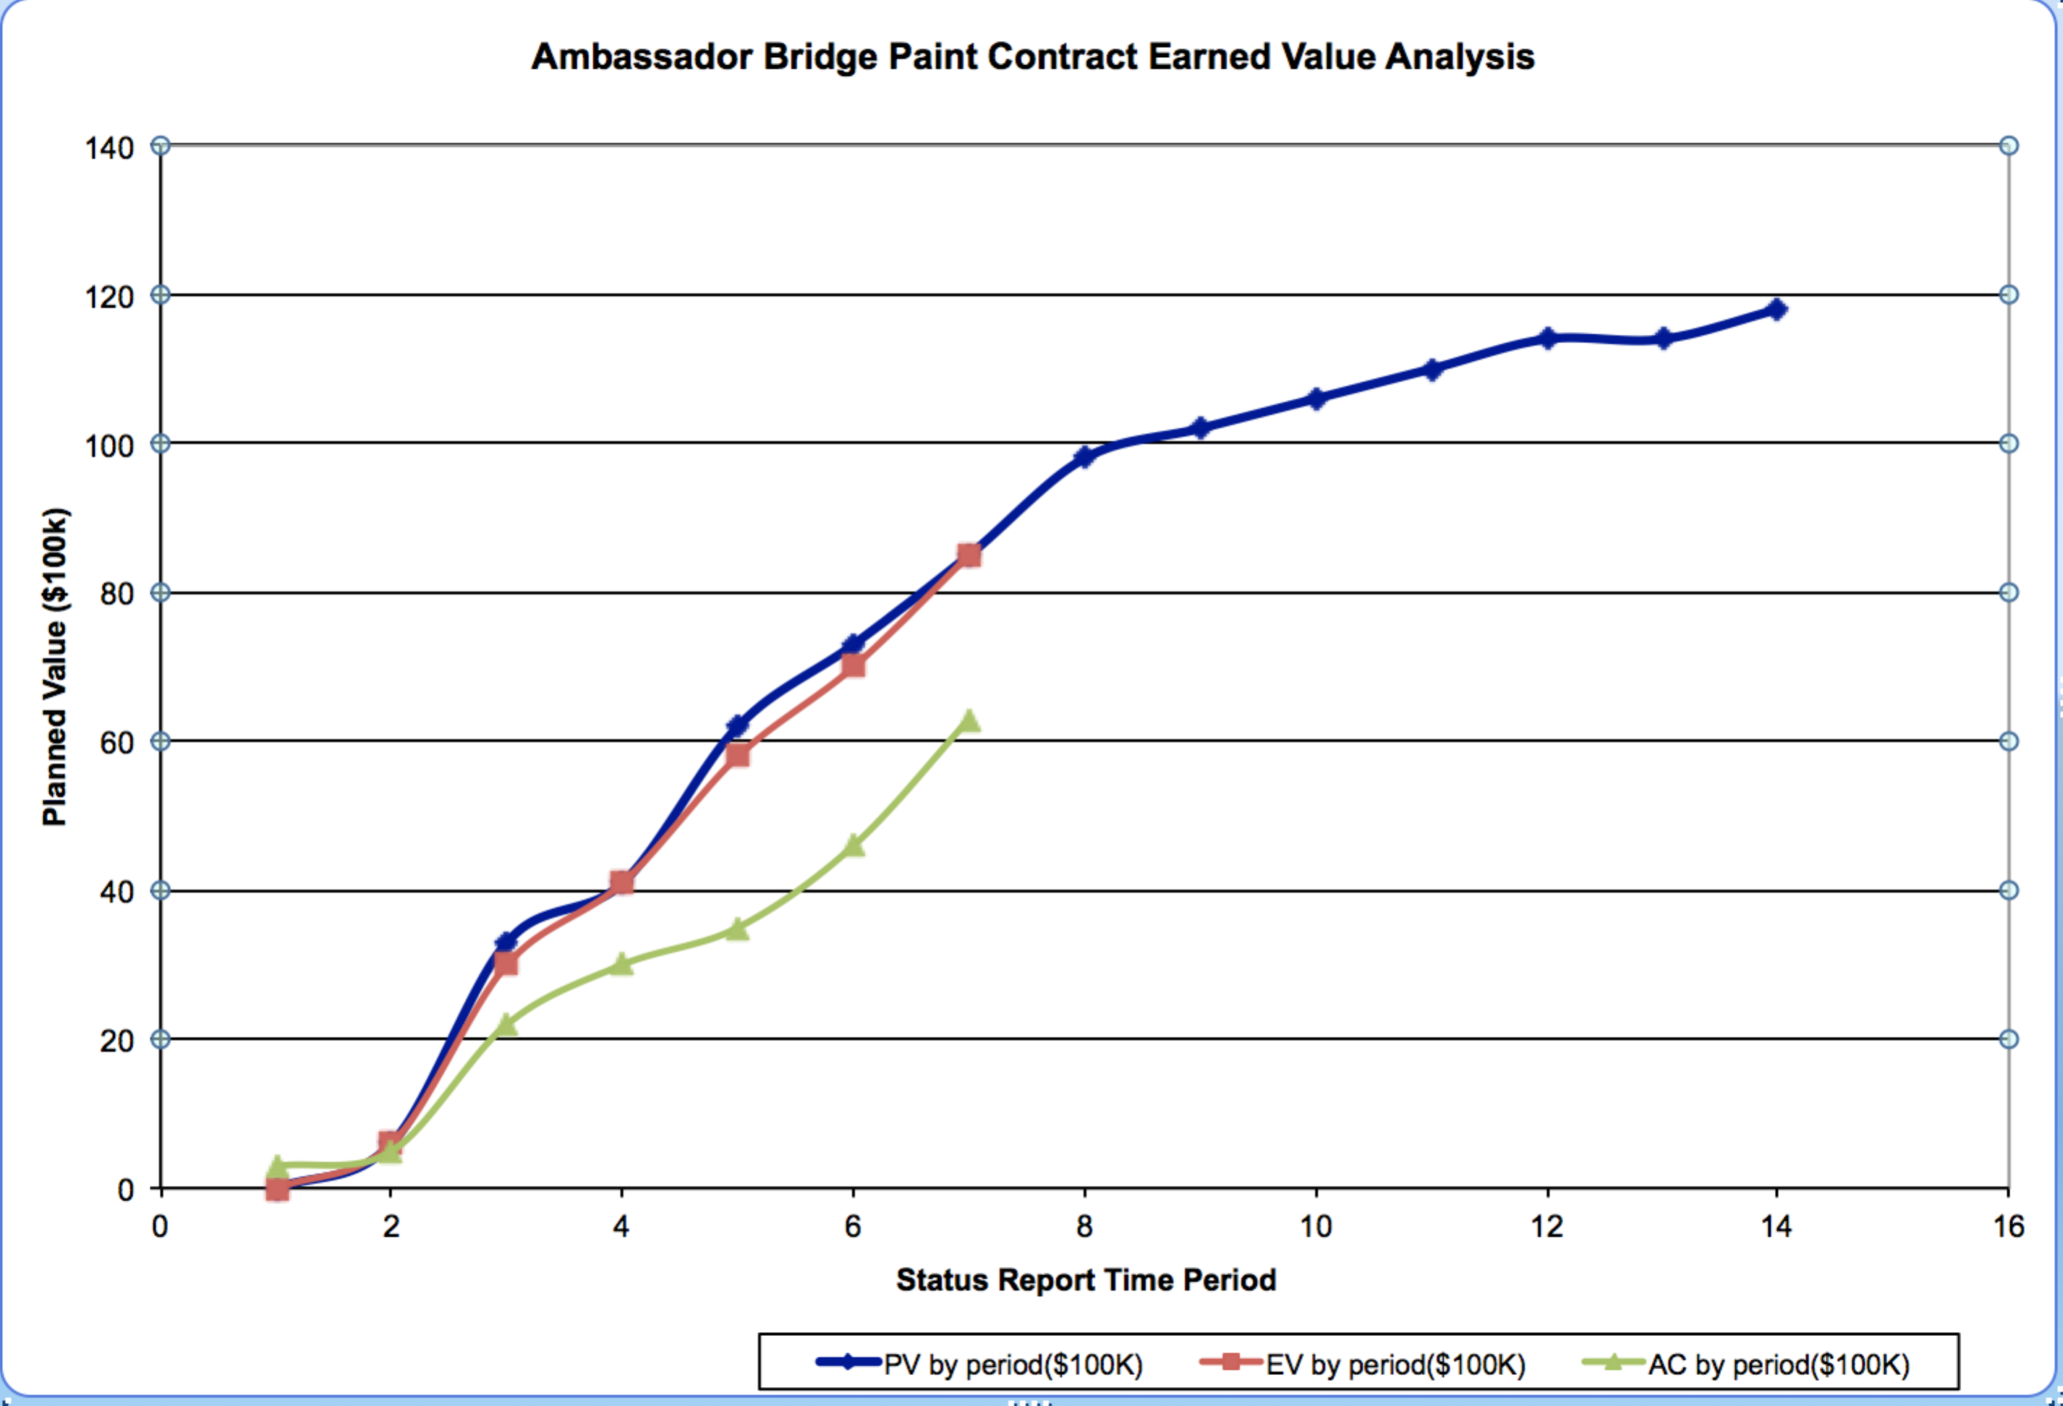

C: At the end of October 2012, which means the end of period 7, the SV = 0 shows the project is accordant to the time schedule, the CV = 22 is positive which means the financial status is good.

D: In order to forecast the next year’s budget, the EAC (estimation at completion) should be calculated. Here we choose the typical formula EAC = AC – (BAC - EV) to compute, consequently for next year, the EAC = 63 + (118 - 85) = 96 ($100K), and we have 118 as the planned total budget or BAC, so as a PM there is still 118-96 = 22 ($100K) budget left, which exceeds the penalty amount $100K, so I am likely to pay when advising my management.

**Question 3 – Emotional Intelligence**

As I watched the videos of Terry Tate, he is a office linebacker who is watching colleagues’ behavior, who is always passionate to offer others discipline and point out their false straight forward. It seems the boss loves him since he can bring the office ‘order’ in very short time. However from EI(emotional Intelligence) aspect, I am not sure Terry is a good leader.

From the explanation of wiki (<https://en.wikipedia.org/wiki/Emotional_intelligence>)

Firstly the EI requires self-awareness, which means the ability to know one’s emotion and recognize their impact on others. Terry apparently have affected others by bringing them the fear. We can see the motivation from Terry’s work, but unfortunately which makes others only negative influence result from his powerful discipline.

Secondly, EI’s another important elements are self-regulation and empathy, which means you can adapt emotion according to the circumstance changing or others’ impact, meanwhile you are will to consider other’s feeling from their standpoints. A powerful leader usually becomes self-centric which is not always helpful to make right decision.

Finally, the teamwork is always a required ability. Terry may be a good watcher and linebacker, but it seems hard to cooperate with. Most colleagues just respect him due to the fear, which easily make them become cynical and careless on the work when Terry is not there.

Above all, I believe the professional worker with good EI will be aware of the self-control, self-regulation empathy and teamwork spirit.